**Deploying an Application to Heroku**

**Lab - 10**

**Heroku:**

* Heroku is a cloud platform as a service supporting several programming languages
* It supports Ruby, Java, Node.js, Scala, Clojure, Python, PHP, and Go.

**Steps Involved:**

1) Create an account in Heroku.com

2) Install Heroku cli to your computer

3) Now click on create app then create one app in Heroku

4) Then connect to git hub

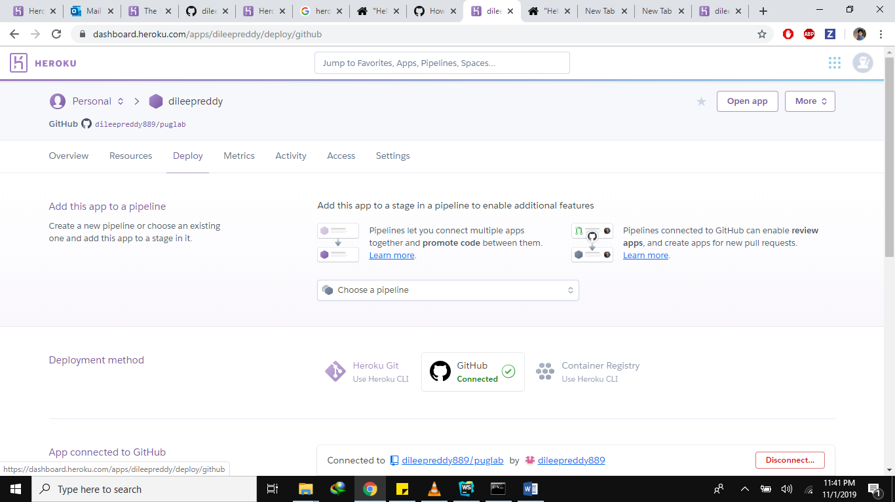

5) Now in command prompt go to your project path and click Heroku login



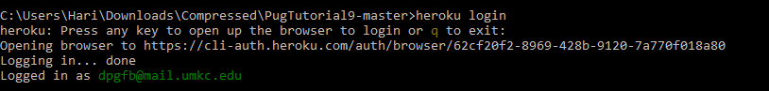

6) Once you logged in with your mail then give git init command. 

7) Now give command as Heroku git: remote -a your app name. It will set a git remote Heroku to your Heroku link.



8) Now give commans as git add . it will add all the changes that has made



9) Now commit your application by giving this command git commit -am “some text”



10) Now push your application to Heroku by giving this command git push Heroku master

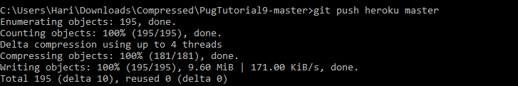

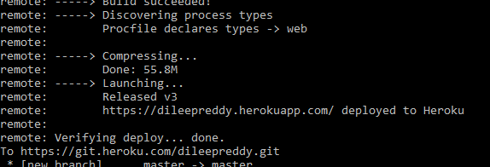

11) Now your application has been deployed to Heroku

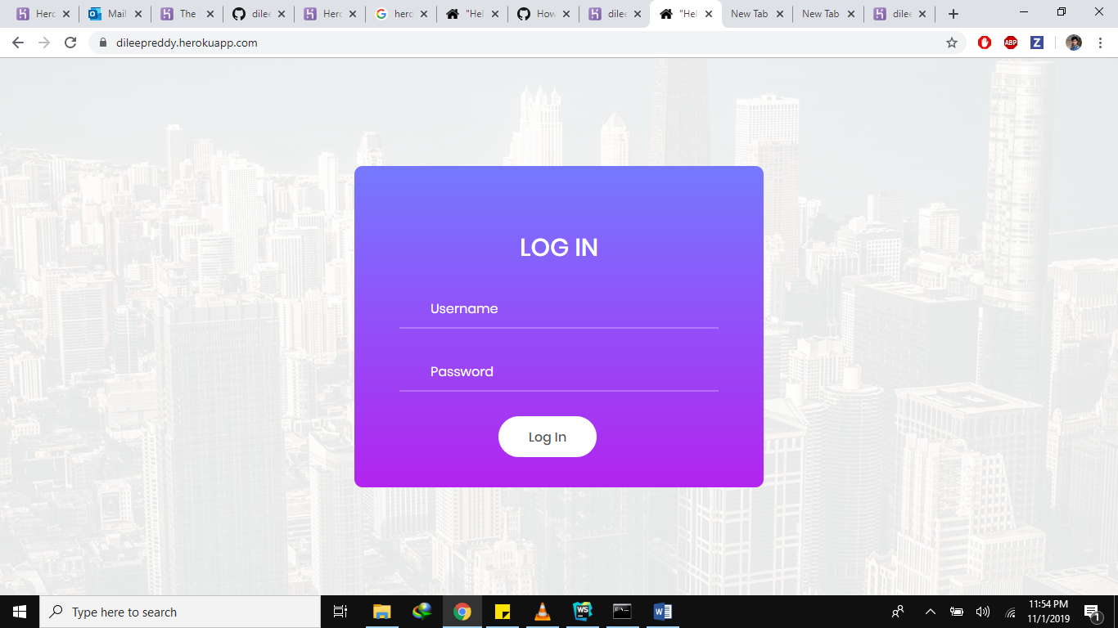

Video Link:

https://drive.google.com/open?id=1ChvVnBwOgnruCQHFI76RIZ-LSAfTqSUl